# Support folder > Create PageClasses folder > Create LoginPage.js file code:

class LoginPage{

// In this class, we have to write the cypress commands as a re-usable methods

Enterurl(){

cy.visit(“https://opensouce-demo.orangehrmlive.com/web/index.php/auth/login”);

}

// Re-Usable method for login

Logintoapp(){

cy.get(‘[name=”username”]’).type(‘Admin’)

cy.get(‘[placeholder=”Password”]’).type(‘admin123’)

cy.get(‘.orangehrm-login-button’).click();

}

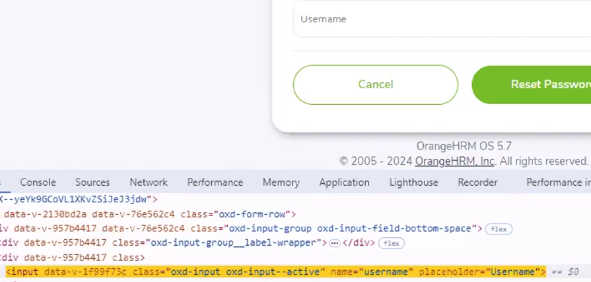

Forgotpassword(){

cy.get(‘.orangehrm-login-forgot’).click();

cy.get(‘[name=”username”]’).type(‘random user’)

cy.get(‘.orangehrm-forgot-password-button--reset’).click()

}

}

export default LoginPage;

# Support folder > PageClasses folder > Create Logout.js file

class Logout{

// re-usable method for the logout operation

logoutofapp(){

//Clicking on dropdown icon

cy.get(‘.oxd-userdropdown-tab’).click();

cy.get(‘.oxd-dropdown-menu’).find(‘[role=”menuitem”]’).each(($ele) => {

if($ele.text() == “Logout”){

cy.wrap($ele).click();

}

})

}

}

export default Logout;

## or use the following code:

class Logout{

// re-usable method for the logout operation

logoutFromApp{

cy.get(‘.oxd-userdropdown-tab’).click();

cy.wait(2000);

cy.get(‘.oxd-userdropdown-link’).contains(‘Logout’).click({force:true});

}

}

export default logout;

# Support folder > PageClasses folder > Create Links.js file

class Links{

// Method to click on the link

clickonlink(linktext){

// I am passing the text of the link from my it block and , in this method I am clicking on it

cy.contains(linktext).click()

}

}

export default Links;

# cypress folder > Integration folder > Create PageTests folder > Create test1.js file

//Here we have to import

import LoginPage from “../../support/PageClasses/LoginPage”;

import Logout from “../../support/PageClasses/Logout”;

import Links from “../../Support/PageClasses/Links”;

describe(‘Orangetests’, () => {

// I have to create object of all the classes.

const loginobj = new LoginPage();

const linksobj = new Links();

const logoutobj = new Logout;

it(‘test - 1’, () => {

//enter url

loginobj.Enterurl();

//login

loginobj.Logintoapp();

//click on admin link

Linksobj.clickonlink(‘Admin’);

//logout

logoutobj.logoutofapp();

});

});

# In the cypress.config.js file

const{ defineConfig } = require(“cypress”);

async function setupNodeEvent(on, config){

//implement node event listeners here

return config;

}

module.exports = defineConfig({

e2e: {

setupNodeEvents,

specPattern: “cypress/Integration/PageTests/*.js”

},

});

